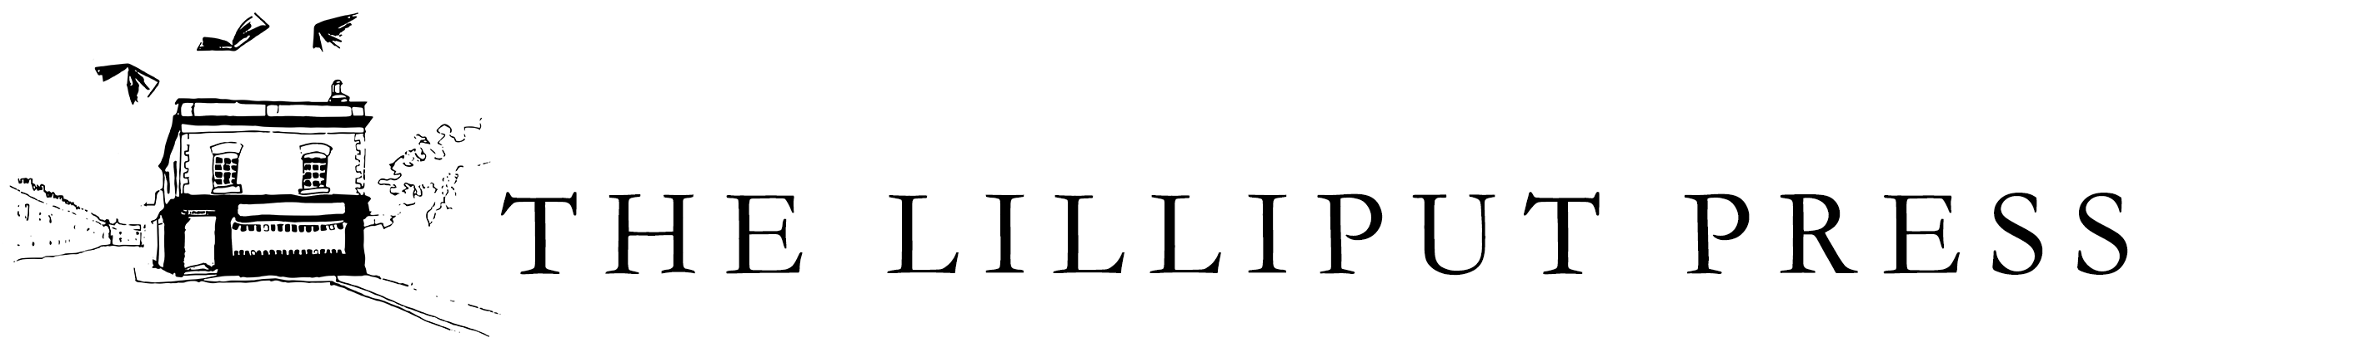

BOARD OF DIRECTORS

Jennifer Brady | Publishing  Jen Brady is Publishing Project Editor and has worked has over 25 years’ experience in the publishing industry covering many areas from copy editing to project management to digital. She is also an author and has had stories published in The Stinging Fly, Southword Journal, Tell Tales Volume 4, Incorrigibly Plural and These Are Our Lives.
David Dickson | History  David Dickson is a Professor in Modern History in Trinity College, Dublin, and has published extensively on the social, economic and cultural history of Ireland, including his award-winning Old World Colony: Cork and South Munster 1630-1830 (Cork, 2005). He was elected a Member of the Royal Irish Academy in 2006.
Kathy Gilfillan | Public Relations & Marketing  Kathy Gilfillan was research assistant at Blackman Harvey in London, 1973-6. She was a copywriter for various Dublin agencies, 1976-90, and a freelance journalist and TV scriptwriter. she is also a board member of the Nerve Centre Derry and Belfast Centre for Digital Skills as well as being on the Advisory Board of the Irish Cultural Centre in Paris.
Antony Farrell | Publishing  Antony Farrell has worked in the Irish publishing industry for over 35 years, having freelanced for the O’Brien Press and Wolfhound Press as an editor before establishing the Lilliput Press in 1984.
Bridget Farrell | Editorial  Bridget Farrell has worked in the environmental NGO sector in Dublin and Brussels, and used to run a restaurant in the south of France. An experienced copy editor with a particular interest in literature in translation, she has acted in an advisory capacity to the Lilliput Press since 2017  on administrative, financial and strategic fronts, and commissions new writing, helping authors with manuscript development.
Seán Farrell | Editorial  Seán Farrell graduated from Cambridge University in 2004 and is a freelance editor, working with writers of both fiction and non-fiction. He has had work published in the Dublin Inquirer, the Bath Flash Fiction Anthology 2018, among others.

