The Cruelty Men  Emer Martin |  | 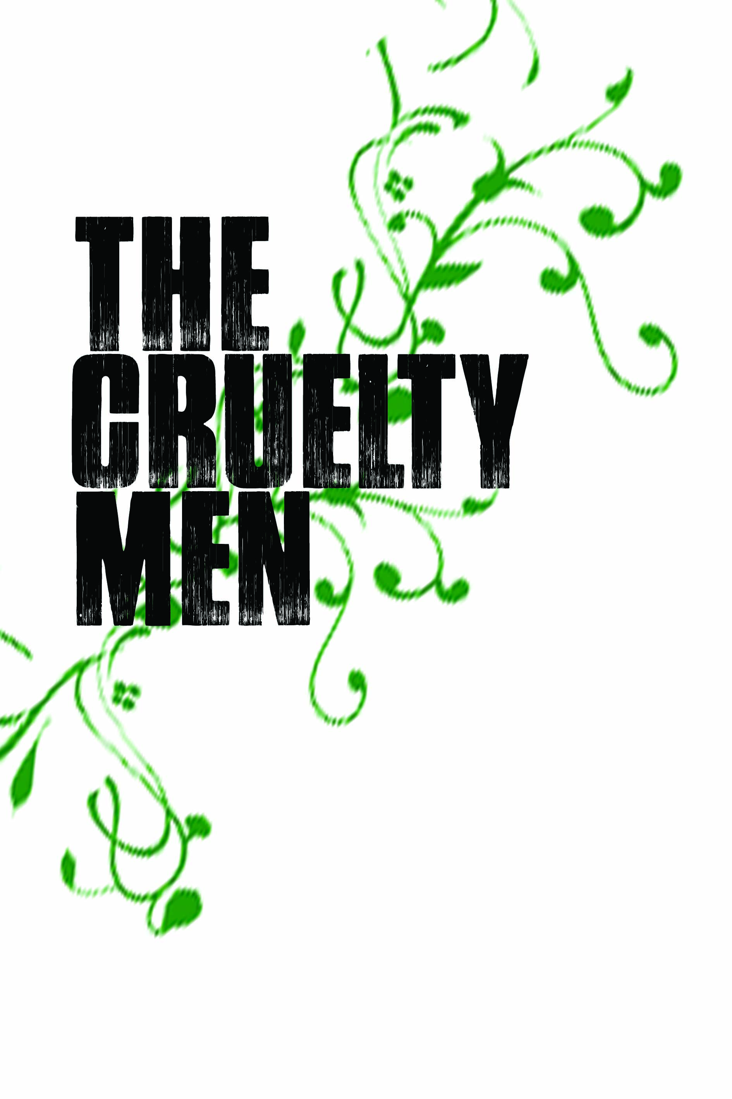
PUBLICATION DATE  PRICE  FORMAT  ISBN | JUNE 2018  €16.00 / £15.00  215 x 136 mm / PBK Flaps / 368pp  9781843517399

POINTS OF NOTE
- This novel is a new work from the prize-winning author Emer Martin. Her first novel, Breakfast in Babylon, won Book of the Year 1996 at the prestigious Listowel Writers’ Week.

REVIEW QUOTES
- ‘The Cruelty Men is a tidal wave that drags you like a piece of debris through Irish history from the ice age to gangland Dublin. A bible of f–cked up Irishness.’ – Irvine Welsh

THE BOOK

This book is a sweeping multi-generational view of an Irish-speaking family who moved from Kerry to the Meath Gaeltacht and the disasters that befall their children in Irish institutions.

Abandoned by her parents when they resettle in Meath, Mary O Conaill is faced with the task of raising her younger siblings alone. Padraig is disappeared, Bridget escapes and her brother Seamus inherits the farm. Maeve is sent to work as a servant to a family of shopkeepers in the local town—later, pregnant and unwed, she is placed in a Magdalene Laundry where her twins are forcibly taken from her.

Martin’s mother and baby homes and Magdalene Laundries are the Irish cousins of Dostoyevsky and Solzhenitsyn’s Gulags; her dispassionate depiction of the ordinary psychotic violence at the heart of families and society in rural Ireland is akin to that of Ferrante’s Naples.

In this novel, two Ireland’s run in stark parallel. A gentle country of fairy rings, blackberry picking, and poker evenings with the local priest masks a system in which the Church and State incarcerate the vulnerable for profit. The intimacy of the first person accounts draws the reader into the world of each character. Their stoicism makes their suffering all the more moving and dignified.

A delightful abundance of poetic and surreal phrases, quips and curses in this book give it a vitality and authenticity. Poignant and swift, The Cruelty Men tells an unsentimental yet emotional tale of survival in a country proclaimed as independent but subjugated by silence.

THE AUTHOR
Emer Martin is a Dubliner who has lived in Paris, London, the Middle East, and various parts of the U.S. Her first novel, Breakfast in Babylon, won Book of the Year 1996 at the prestigious Listowel Writers’ Week. More Bread Or I’ll Appear, her second novel, was published internationally in 1999. Her third novel, Baby Zero, was published in the UK and Ireland in 2007, and released in the U.S. in 2014. She has worked as a theatrical producer and publisher, founding publishing cooperative Rawmeash in 2014. Emer was awarded the Guggenheim Fellowship in 2000. She now lives between California and Co. Meath, Ireland.

